Syllabus E version December 16 revisions

ENG 106: Patricia Rozema: Fantastical Feminist Filmmaker

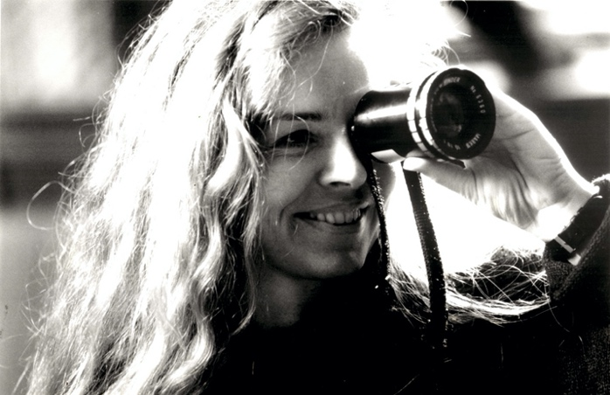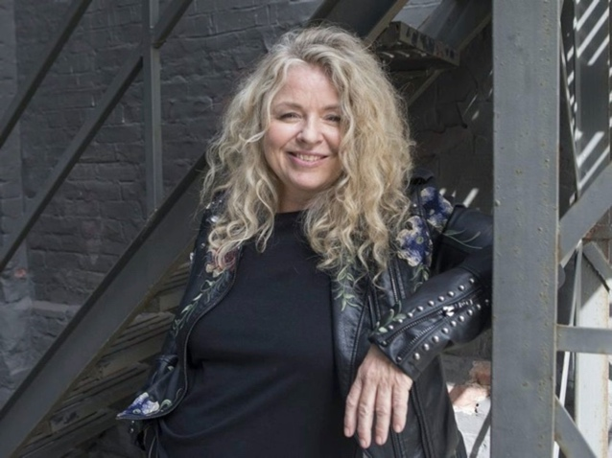

Who is Patricia Rozema? You will find out as we immerse ourselves in watching her films and writing about this brilliant independent director from Canada. Screening five of her diverse films, we will write reviews, interview scripts and essays, and research and compose a hypothetical film festival of her work. Thanks to Rozema’s generosity, we have been able to arrange a Zoom visit with the director.

Rozema’s quirky debut film, *I’ve Heard the Mermaids Singing* in 1987 won the Cannes Film Festival, 1987: Prix de la Jeunesse [youth prize]; it was followed by *When Night is Falling* (1999), *Mansfield Park* (a 1999 hotly contested revision/adaptation of Jane Austen’s novel), her apocalyptical Into the Forest (2016) and most recently her stunning *Mouthpiece* (2018). (FYW)) (Humanities)

Professor Leslie Kathleen Hankins, 205 South Hall, [lhankins@cornellcollege.edu](mailto:lhankins@cornellcollege.edu)

Office hours can happen most quickly via ZOOM; just send me an email and we can set up a time. In person office hours: Friday after class.

Jennifer Ferrell, Writing Studio Director, Cole Library, [jferrell@cornellcollege.edu](mailto:jferrell@cornellcollege.edu)

Greg Cotton, Library [gcotton@cornellcollege.edu](mailto:gcotton@cornellcollege.edu)

*This is a W (Writing) course; we are here to engage with our inner writer. We all have one hidden away or not. Writing is not merely a gift some people have. It is a skill to develop. In this course, you will be expected to write and write and rewrite and revise many times. Writing is like any form of exercise; the more you do it, the more you can do. Good writers draft and redraft and redraft and redraft again. Put time and effort into your writing. In this W course we will write daily. English 106 is a demanding course, with a lot of critical reading, writing, and thinking. Be prepared for hard work—hard work that will pay off in improvement in your writing, which will help in your overall college career.*

**Required Texts:**

*The Transition to College Writing.*

*They Say, I Say: The Moves that Matter in Academic Writing*

*A Short Guide to Writing about Film. Corrigan. Any edition.*

**Learning Outcomes for the Course:**

* Students will experience guided practice in critical reading and viewing. (Inquiry, Reasoning)
* Students will understand writing as a process that involves multiple stages. (Communication)
* Students will write appropriately for a given audience, purpose, and context. (Communication, Intercultural Literacy)
* Students will gain practice in developing and sustaining an argument with evidence. (Inquiry, Reasoning, Communication)
* Students will evaluate, cite, and document sources appropriately, including interviews and reviews. (Inquiry, Reasoning, Ethical Behavior)
* Students will learn to incorporate feedback and revision. (Communication)

How to reach me: I enjoy working with you and encourage you to set up virtual time with me. The best way to reach me is by email: [lhankins@cornellcollege.edu](mailto:lhankins@cornellcollege.edu) so we can schedule a time.

CLASS EXPECTATIONS:

If you are ill in any way that could be contagious, alert me and stay home; we do not want to be a spreader event. If appropriate for your symptoms, arrange for a Covid test. The R virus is equally dangerous to those of use with compromised lungs.

Of course, if you become seriously ill (Covid or whatever) we will work together to help you to withdraw from the course, or to do what is needed to continue the course from quarantine).

If necessary for health or weather conditions, the course may switch to ZOOM at a moment’s notice. Check your email early morning and late night--twice a day-- for course information and Moodle alerts! Because a course needs to be responsive and alive, be prepared for changes in the syllabus. See me immediately if you have any problems keeping up with the course. It is more difficult to repair serious gaps as the block goes on.

You must be present in class daily. You must be present for conferences, group meetings, presentations, and workshops in order to pass the course. Your classroom presence contributes to your grade; for workshops and discussions, your absence cannot be made up to your peers. You should not have absences, but be aware that if you do, you may fail the course with more than 2. It is up to you to contact classmates for information you may have missed.

Late work may not be accepted, and if accepted may be penalized by at least a letter grade. All projects and papers must be turned in to pass the course.

**Wise tips:**

Use the Writing Studio regularly. Make appointments to meet with the Writing Director, Jennifer Ferrell, often. In this course, you have the opportunity to really go through Boot Camp for Writers; don’t miss this chance to work with experts and transform your writing. You may be required to make regular appointments with the Writing Associate in addition to the usual appointments.

Tap the resources of our Consulting Librarians. Greg Cotton is the research expert on tap for our course. Of course, no matter how rushed you are, be considerate of their time and make appointments to allow time for calm work.

Keep all of your writings (and drafts/notes/lists/clusters/freewriting) throughout the course so you can look over your work. Always keep the professor’s comments too. If you keep a writing journal, that will also help to document your progress. Remember to upload your paper for the First Year portfolio.

Grade Standards and Guidelines.

Bring your intelligent, thoughtful, articulate self to class each day, and to all your work. Rather than asking what you have to do for x grade, aim for the absolute best you can bring to the course.

At Cornell College, we want you to do well and to work to your highest ability. We would like to see all students earn the best grades they are capable of earning. Remember that professors don’t “give’ you grades; you earn them. College grades sometimes come as jolt after high school because in college courses the bar is higher; you are expected to earn your grades through diligent, thorough, thoughtful and committed hard work. You don’t earn a grade by simply showing up. Consider a sports/arts analogy. Do we think a basketball player has done his or her job by just showing up for the game? Do we think entertainers earn an Academy Award by doing the minimum, learning all the lines and working hard? Or do we expect them to do all that and more, to do a superlative job? Let’s apply similar standards for academic work. You are expected to put solid intense effort into every course on the block plan, and to hand in all work at an acceptable level. You may not pass the course if you are missing ANY assignments. You may fail the course with 2 or more absences.

If you do poor work, miss class and do not contribute to the class, you may earn an F.

If you show up regularly and do all the work but not all that well you may earn a D.

If you do all the work and do it adequately, you may earn a C. You cannot pass without doing all the work at a passing level, and you are expected to challenge yourself.

To earn a B, show up eagerly, do all the work very well, set high standards for yourself and meet them, contribute to the class in meaningful ways, support your peers and the professor in building an academic intellectual community, and write, research and revise very well.

To earn an A, do all of this superbly, going well beyond the class expectations.

Plagiarism: Always cite sources and include a Works Cited if you used any sources—and that includes web finds and other students’ papers. Learn what correct MLA form is and use it regularly. Plagiarism may result in failing the course. Using a paper you have handed in for another course, or which someone else has handed in for a course counts as plagiarism. You are in this class to work on your writing; using someone else’s writing will not help you. Plus, plagiarism = failure.

**Papers and Projects: 20% each**

1. Digital journal of daily writing for the course, including responses to each film and interview we see, and in class writing assignments (in class writings can be typed up after class). freewriting, etc.15 pp minimum double spaced typed.
2. Analysis informed Review of *I’ve Heard the Mermaids Singing*. 4 pages+
3. Project/Paper based on interview with Rozema.

--Interview prompts: 10 questions with rationale. Provide examples (at least 5) of the successful interview questions from at least 3 interviews with Rozema.

--Conduct of Interview. How you present yourself during the entire interview: attentive, alert, eager, smart, thoughtful.

--3+ that in page paper incorporating insights from entire interview.

Cover letter.

1. Group Project composing film festival materials.

Sample materials such as posters, brochures, commentary on each film you choose, etc. Presentation.

1. Revision/development of *Mermaids* Review paper 2. 5++ pages + sources

In this course we will consider innovative ways to conduct research via the Interview, brainstorm about the most productive and deep interview strategies, and compose and workshop interview questions to be sure they are the best they can be.

We will conduct practice interviews and analyze their effectiveness, and then have a Zoom interview session with the director, Patricia Rozema. After that interview, students will transcribe the interview and analyze the interview for the information it provides and the effectiveness of the interview strategies.

From the interview and analysis, as well as from the readings and film-screenings in the class, students will then prepare individual final papers and a group project on a hypothetical film festival on Rozema: design flyers, programs and other materials that involve written text and visual text.

Students will

------study ways to encounter film as scholars and intelligent critics, and will write papers of film reviews, film critiques, and annotated bibliographies of research in progress.

------ keep ongoing digital journals about the course and all screenings.

In addition to notes on the films and articles, the journals will trace students’ responses to the films, and responses to and questions for the director.

------ work in groups to design the final film festival projects.

------ work in groups of 3 or so to study and plan interview questions for Rozema, and will consult existing interviews to fine tune questions that are specific and compelling.

Week 2 will have research session in which students research Interviews in general as well as gather specific interviews and reviews involving Rozema and her work. We will work with those interviews as a class to consider which interview strategies seem most intriguing and productive, so we can hone our own.

We will regularly view interviews and share reviews in class

**SCHEDULING SYLLABUS (always in flux! Be ready for revisions)**

**WEEK ONE**

Monday November 28: 12-3. Introduction.

Screen *I’ve Heard the Mermaids Singing*. (1987)

https://www.poetryfoundation.org/poetrymagazine/poems/44212/the-love-song-of-j-alfred-prufrock

Assign: Read chapters 1-2 in Corrigan.

Read *Transitions* pp. 20-29ff.

Write film response of 2+ pages in digital journal.

Tuesday November 29:

*I’ve Heard the Mermaids Singing*.

Readings from Corrigan and *Transitions* textbook:

Read *Transitions* section on being a Predatory Reader, p. 32ff, and think of being a predatory viewer.

Wednesday November 30.

*I’ve Heard the Mermaids Singing*.

Writing about film. Reviews and the paper. These Review papers assume your readers **have** seen the films we have seen, and should include analysis of specific film elements such as a shot analysis or short scene analysis (combining film analysis with review)

Assign: *Transitions* Ch 4 “How Good Writing Gets Written.”

Assign: *They Say, I Say*. Part 1. And Part 2: 6.

Thursday December 1:

1-3 draft workshop in classroom with Jennifer Farrell for drafts of the paper that is a Review plus some critical analysis. Remember, these papers assume readers **have** seen the films we have seen, and should include analysis of specific film details (combining some film analysis with review)

Friday December 2:

Paper due at noon.

*When Night is Falling.* (1 hour 33 minutes) (1995)

Assign: “The Warm Art of the Interview” on Moodle. Print up a hard copy for you to have on hand throughout course.

WEEKEND DECEMBER 3-4

WEEK TWO

Monday December 5: Morning class 10-11in Library 2nd floor computer room, taught by Greg Cotton, librarian on interviews and reviews for research.

12-3 108 Library *When Night is Falling*.

*Passion: A Letter In 16mm* (1985, dir. Patricia Rozema)

Tuesday December 6:

*Mansfield Park* (1999) 112 m.

Wednesday December 7:

*Into the Forest*

Interviews/Reviews and Responses on the film.

Thursday December 8:

*Afternoon in classroom 1-3* Working on Writing

Evaluating Review papers; working with *They Say I Say* prompts.

Friday December 9:

*Conferences with professor about major REVISION to paper 1.*

NOTE: ALL STUDENTS HAVE REQUIRED APPTS WITH JENNIFER FARRELL ABOUT THE REVISION PROJECT BEFORE THE DUE DATE.

WEEKEND DECEMBER 10-11

WEEK THREE

Monday December 12: 1-3 *Mouthpiece.* (2018) 1 hour 31 minutes.

Read handout and readings on Interviewing project/interviewing on Moodle.

Tuesday December 13: I1-3 Interview Workshops and Strategies

Group work to fine tune questions.

Wednesday December 14:

Interview practice and planning.

Thursday December 15: 1-3

Required by all! ZOOM INTERVIEW WITH ROZEMA to be recorded (remind me to record!)To be done on your computers so you don’t have to be masked!!

Friday December 16: ZOOM morning class 10-12 Discuss interview.

1-3 workshop on writing a paper with Interview sources by Jennifer Farrell in classroom. Interview project paper due Sunday at noon.

The interview project is in 5 parts:

1. Your interview questions you have already handed in.
2. Your conduct and participation during the interview.
3. Now you hand in the remaining parts:
4. Examples of successful interview questions from at least three interviews you read. Quote them and Cite them MLA Style in your bibliography for the project.
5. 3+ (plus any visuals) paper/essay about the Interview with Rozema we conducted. You may incorporate how it affected you—what stood out to you, and (this would be the main body): insights about Rozema as a director that the interview revealed to you. Transcribe any passages you want to quote (and do quote a lot!). You may focus your paper on a particular topic that came up in the interview, depending on your own interests. What did you learn? Share that with your reader.
6. Bibliography of the interviews and any other sources you may bring in.
7. VI. The one page cover letter to me should tell about your interview and writing process and how you went about organizing this wealth of material into your paper.

WEEKEND DECEMBER 17-18

WEEK FOUR:

Monday December 19:

Afternoon: 1-3 workshop with Jennifer Ferrell on polishing final drafts of revision papers Bring your penultimate draft to work on! Zoom Conferences throughout day with Hankins as needed.

Tuesday December 20: you must attend classes this day.

ZOOM 10-12: Group brainstorming on Film Festival ideas with Hankins. Groups will each brainstorm about and write up to share their vision of a Rozema film festival, and each group will take on specific tasks in collaborative writing: designing the film program, posters for the festival, blurbs about the films, or other contributions of their choice.

1-3 Groups continue to work on and share film festival contributions! Costumes from any Rozema film, with a one paragraph description and selfie worth points!!

Wednesday December 21: **Happy holidaze. No in person class.**

Polished and REVISED REVIEW PAPER and any remaining course materials must be uploaded by midnight.

**Course Protocols**

On Resilience (thanks to Jen Rouse for sharing)

*Each day you have an invitation to learn in this course, and your attendance and participation are an integral part of what keeps our learning community strong. Sometimes we slip up. We forget to set an alarm. We don’t expect a wave of depression to take over our day. And we miss class or have a moment where we aren’t certain we can finish class. I encourage you to find what I know is within you to breathe through this and keep going. If you’re in class, take a break and come back. If you miss class, come back to the next class period. Whatever you do, don't give up. Communicate with me about what happened and your plan to keep trying. Building up resilience to the things that challenge us is a part of the human experience. It takes practice. I am here to help you practice.*

*Recordings of Class Sessions*

I will record the ZOOM interview for course use. Recordings are not to be shared beyond the class.

*Required Mask Policy*

Masks are required during all in-person instructional time in this class. Appropriate accommodations for students with disabilities will be incorporated into our mask policy and may include the use of microphones or clear face coverings. If you have a health condition that prevents you from wearing a mask, you may wear a face shield if you have documentation from your medical provider on file; you can also make an appointment at the student health center to be approved for a face shield. Non-compliance will result in a conduct report to the Dean of Students, which can result in removal from the course.

KN95 masks are preferred for the most effective prevention of transmission and I strongly encourage that you use these on campus. Masks are available at the Information Desk in Thomas Commons, at the Circulation Desk in the Library, and in the Office of Student Affairs on the first floor of Old Sem.

*Illness Policy*

**If you are experiencing COVID-19 symptoms**, ***do not attend class***. Perform a home test or contact Director of Student Health Services Lynn O’Brien at [student_health@cornellcollege.edu](mailto:student_health@cornellcollege.edu) immediately to arrange a COVID-19 test at the Health Center.

If you need to isolate due to COVID-19, or if you become unable to attend class for any other health reason, contact me as soon as possible to determine if you are able to continue in the class. A [Withdrawal for Health Reasons](https://www.cornellcollege.edu/registrar/omnibus/index.php/drop_a_course) may be required.

*Positive COVID Test Policy*

**If you** **test positive**: Please isolate yourself in your room, contact Director of Health Services Lynn O’Brien at [student_health@cornellcollege.edu](mailto:student_health@cornellcollege.edu) and wait for instructions. A representative from Student Health will contact you to discuss your test and provide you with instructions for isolating and begin contact tracing of on-campus interactions.

If you test positive for COVID-19 during the block and need to isolate, you need to inform me directly; the Health Center cannot inform me on your behalf.

*Close Contact Policy*

If you are named as a close contact of someone who has tested positive on campus, you will be notified by Student Health. (If you learn that you have been in contact with someone who has tested positive from an off campus exposure, you must inform Director of Health Services Lynn O’Brien at [student_health@cornellcollege.edu](mailto:student_health@cornellcollege.edu). We will determine your status and next steps using the [CDC guidelines](https://www.cdc.gov/coronavirus/2019-ncov/daily-life-coping/determine-close-contacts.html). To prepare for the possibility of needing to conduct contact tracing, we will have assigned seating and/or I will take a daily photo of the classroom to document seating proximity.

1. Academic Honesty expectations.   
   Cornell College expects all members of the Cornell community to act with academic integrity. An important aspect of academic integrity is respecting the work of others. A student is expected to explicitly acknowledge ideas, claims, observations, or data of others, unless generally known. When a piece of work is submitted for credit, a student is asserting that the submission is their work unless there is a citation of a specific source. If there is no appropriate acknowledgement of sources, whether intended or not, this may constitute a violation of the College’s requirement for honesty in academic work and may be treated as a case of academic dishonesty. The procedures regarding how the College deals with cases of academic dishonesty appear in The Catalogue, under the heading “Academic Honesty."
2. Students with disabilities.   
   Cornell College makes reasonable accommodations for persons with disabilities.  Students should notify the Coordinator of Disability Services and their course instructor of any disability related accommodations within the first three days of the term for which the accommodations are required, due to the fast pace of the block format.  For more information on the documentation required to establish the need for accommodations and the process of requesting the accommodations, see <https://www.cornellcollege.edu/student-success-center/disabilities/index.shtml>.